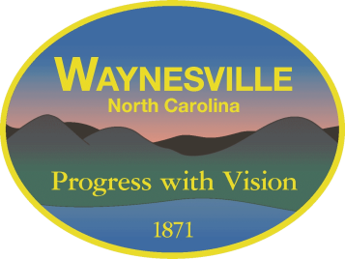Gary Caldwell, Mayor Robert W. Hites, Jr. Town Manager

Julia Freeman, Mayor Pro Tem William E. Cannon, Jr., Town Attorney

Clarence “Chuck” Dickson, Alderman

Jon Feichter, Alderman

Anthony Sutton, Alderman

**NOTICE OF SPECIAL MEETING**

A special called meeting of the

Town of Waynesville Board of Aldermen

will be held on Tuesday, May 26th, 2020 beginning at 3:00 pm in the Public Services Building Training Room, located at 129 Legion Drive Waynesville, NC 28786

The purpose of this meeting is Budget Review

A full agenda can be found at [www.waynesvillenc.gov](http://www.waynesvillenc.gov)