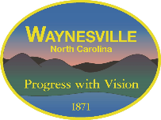

The Town of Waynesville is seeking proposals from qualified licensed general contractors to construct a restroom facility at the Obama King Park. The park is located at the intersection of Calvary and Craven Street. A complete bid packet and drawings are available for download at www.waynesvillenc.gov. Please submit bids to the Purchasing Department, 129 Legion Drive, Waynesville, NC 28786 by Tuesday, September 05, 2023 at 10:00 AM.

