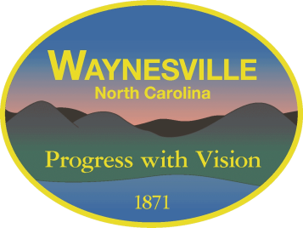
Gary Caldwell, Mayor Robert W. Hites, Jr. Town Manager
Julia Freeman, Mayor Pro Tem Martha Bradley Town Attorney
Jon Feichter, Alderman
Chuck Dickson, Alderman
Anthony Sutton, Alderman

CANCELLATION

The regular meeting of the

Town of Waynesville
Board of Aldermen
scheduled for September 27th, 2022
has been canceled
due to a lack of actionable agenda items

The next regularly scheduled meeting will be held
on October 11th, 2022

