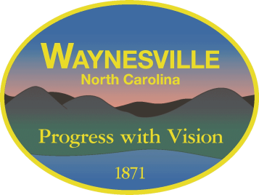
Gary Caldwell, Mayor Robert W. Hites, Jr. Town Manager
Julia Freeman, Mayor Pro Tem William E. Cannon, Jr., Town Attorney
Clarence “Chuck” Dickson, Alderman
Jon Feichter, Alderman
Anthony Sutton, Alderman

Notice of
Meeting
Cancellation

The regular meeting of the
Town of Waynesville
Board of Aldermen
scheduled for May 26, 2020
has been CANCELED.

A Special Meeting, that begins at
3:00 PM in the Public Services training room, will take the place of the regular meeting.

