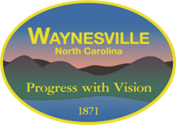

TOWN OF WAYNESVILLE

REQUEST FOR QUALIFICATIONS (RFQ)

ENGINEERING SERVICES
Engineering Report, Design, Bidding, and Construction Administration & Observation Services

- INTRODUCTION
The Town of Waynesville has been awarded funding from the North Carolina Department of Environmental Quality (NCDEQ), Division of Water Infrastructure, for wastewater system improvements totaling $14,990,531.00.
The Town is soliciting statements of qualifications from qualified engineering firms to provide professional services for the Little Champion Pump Station Project and Wastewater Treatment Plant (WWTP) Improvements Project.

2. PROJECT DESCRIPTION

2.1 Little Champion Pump Station Project
This project includes:
- Replacement of an existing junction box with a new pump station located outside the 500-year floodplain
- Associated gravity sewer line replacement
- Force main replacement and repairs
Funding Sources:
- $5,000,000 — Clean Water State Revolving Fund (SA-HMW Program, “SRF Helene”) – 100% principal forgiveness
- $3,000,000 — Wastewater State Reserve Grant
- $490,531 — Viable Utility Reserve Grant
2.2 WWTP Improvements – Phase 1
Improvements at WWTP include:
- Demolition of the existing junction box that receives wastewater
- Design and construction of a new junction box and 36-inch conveyance line connecting it to the treatment plant
- Installation of a septage receiving station capable of metering influent and separating grease from other waste
- Headworks improvements
- Installation of an ultraviolet (UV) disinfection system protected from flooding to replace the existing chlorine contact basin located within the floodplain
The project is contingent upon:
- Approval of the Engineering Report (ER) by the North Carolina Department of Environmental Quality (NCDEQ)
- Final approval of the State Revolving Fund loans

2.3 WWTP Improvements – Phase 2 (Pending Funding)
This phase may include:
- Conversion of existing tanks for flow equalization and sludge storage
- Floodproofing and pump replacements at pump stations
- Effluent reuse system improvements
- This additional phase of the projects is currently pending funding. Funding for the WWTP improvements project includes $6.5M in Viable Utility Reserve grant funding for Phase 1, with an application pending for Phase 2.

3. SCOPE OF SERVICES
The selected firm will provide professional engineering services including, but not limited to:

3.1 Pre-Construction Services
- Preparation of an Engineering Report (ER)
- Preparation of Environmental Information Documentation
- Obtaining all required regulatory approvals
- Coordination with NCDEQ and funding agencies

3.2 Design and Bidding Services (Post Release of Funds)
- Preparation of final design plans, specifications, and bid documents
- Bid process management, including:
  - Advertisement for bids
  - Pre-bid meetings
  - Bid opening and tabulation
  - Recommendation of award
- Preparation and issuance of Notice to Proceed

3.3 Construction Phase Services
- Conduct pre-construction conference
- Provide construction administration and observation services
- Prepare construction observation reports
- Review and approve:
  - Pay applications
  - Change orders
- Coordinate with Town and contractor throughout construction

3.4 Project Closeout
- Conduct final inspections and testing
- Provide record (as-built) drawings
- Submit documentation to regulatory agencies
- Prepare operation and maintenance manuals
- Assist with funding agency closeout

3.5 Funding Administration Services
- Preparation of reimbursement requests
- Compliance and reporting assistance
- Coordination with funding agencies

4. SUBMISSION REQUIREMENTS
Statements of Qualifications must include the following:

4.1 Firm Information
- Legal name, address, phone number, and email
- Firm ownership and key personnel

4.2 Relevant Experience
- Experience with similar water/wastewater projects
- Project descriptions including:
  - Location
  - Construction cost
  - Scope of work
- At least three (3) client references from projects completed within the past five (5) years

4.3 Project Team
- Key staff qualifications and roles
- Relevant project experience of assigned personnel

4.4 Capacity and Performance
- Current workload and availability
- Ability to meet project schedule
- History of cost control and quality performance
- Experience administering state and federal funding

4.5 Project Approach
- Proposed work plan
- Project schedule

4.6 Compliance Documentation
- Proof of eligibility and non-debarment status

5. EVALUATION CRITERIA
Submissions will be evaluated based on the following:
Criteria | Points
Qualifications and Reputation of Firm and Personnel | 20
Ability to Meet Schedule and Budget Requirements | 20
Experience with Funding Agency Programs | 15
Relevant Project Experience | 20
Past Performance with the Town | 25
Total | 100

6. SELECTION PROCESS
A selection committee will review all submissions and rank firms based on the evaluation criteria. The highest-ranked firm will be recommended to the Town Council for contract negotiations.

7. CONTRACT NEGOTIATION
- The Engineering Report contract will be negotiated separately from design and construction services
- Subsequent contracts will be contingent upon funding approval and release of funds
- Compensation and scope will be clearly defined in each agreement

8. SUBMISSION DEADLINE AND CONTACT INFORMATION
Deadline:
3:00 PM, May 28, 2026
Submit To:
Town of Waynesville Town Hall
16 S. Main Street
Waynesville, NC 28786
Attention:
Rob Hites, Town Manager
Email Submissions:
rhites@waynesvillenc.gov
Phone:
828-452-2491

9. ADDITIONAL INFORMATION
Respondents may review the project application and supporting materials on the Town of Waynesville website under:
“Little Champion Pump Station / WWTP Improvements”

10. EQUAL OPPORTUNITY
The Town of Waynesville is an Equal Opportunity Employer and encourages participation from:
- Small businesses
- Minority- and women-owned firms
- Historically underutilized businesses (HUBs)
- Section 3 business concerns

11. PROJECT SITE PHOTOS
The following images provide general context for the project locations and existing conditions. Photos are for reference only and may not represent all site conditions.
11.1 Little Champion Pump Station Area
Figure 1. Existing Little Champion junction box structure with open wet well and grating; note aging concrete, exposed openings, and proximity to flood-prone area.
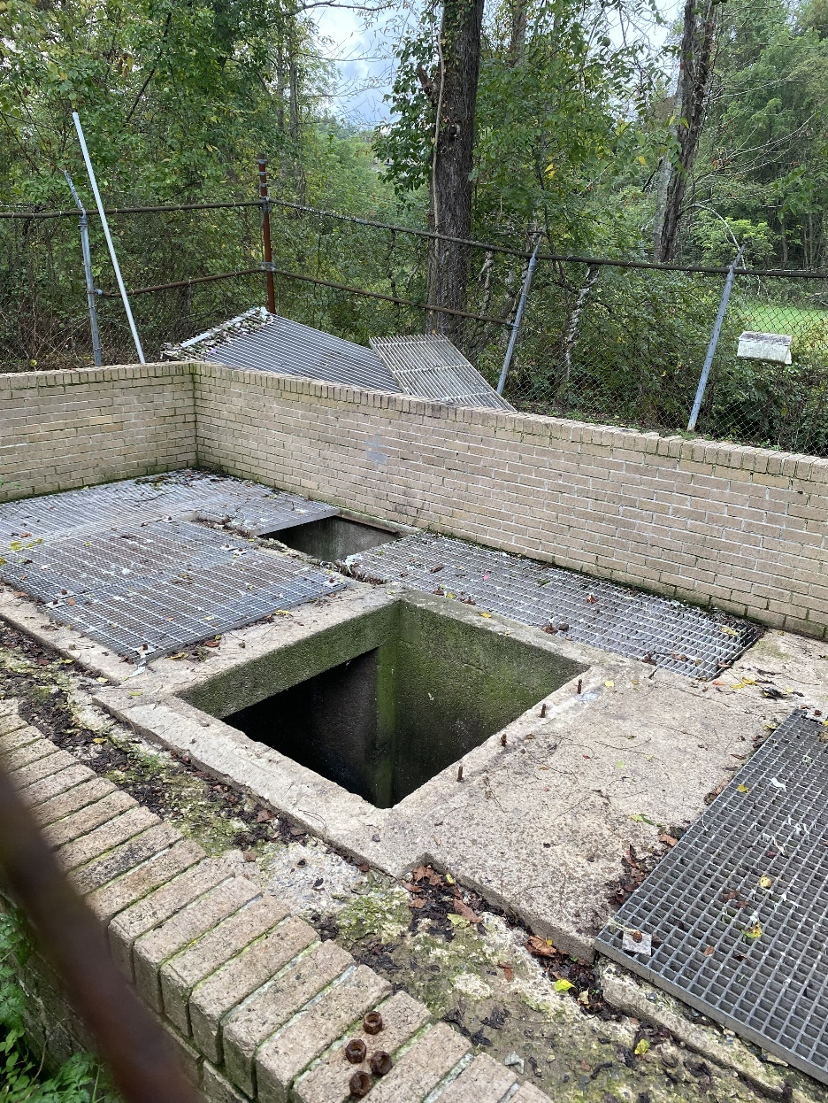

11.2 Wastewater Treatment Plant (WWTP)
Figure 2. Existing headworks area including mechanical bar screen and screenings handling equipment; visible corrosion, aging infrastructure, and exposed components.

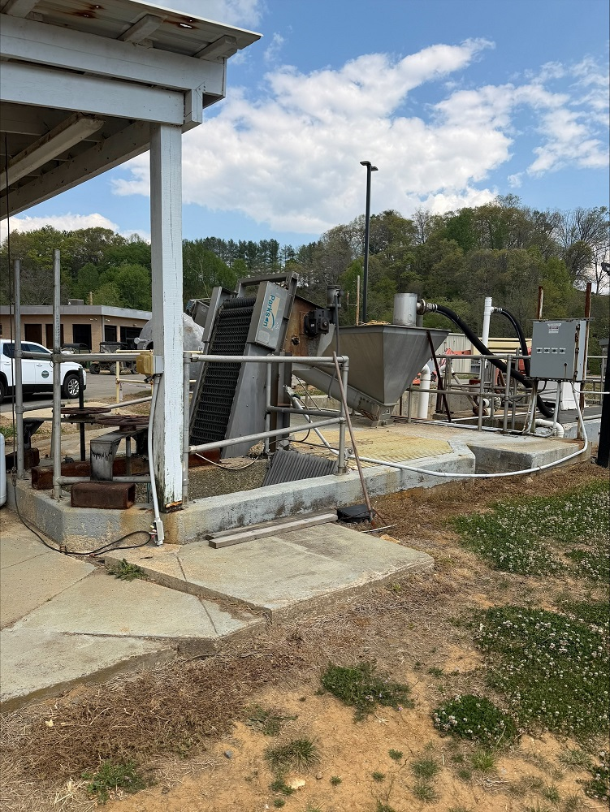

Figure 3. Existing influent junction box and piping with adjacent control panel; note confined access, corrosion, and need for improved flood resilience.
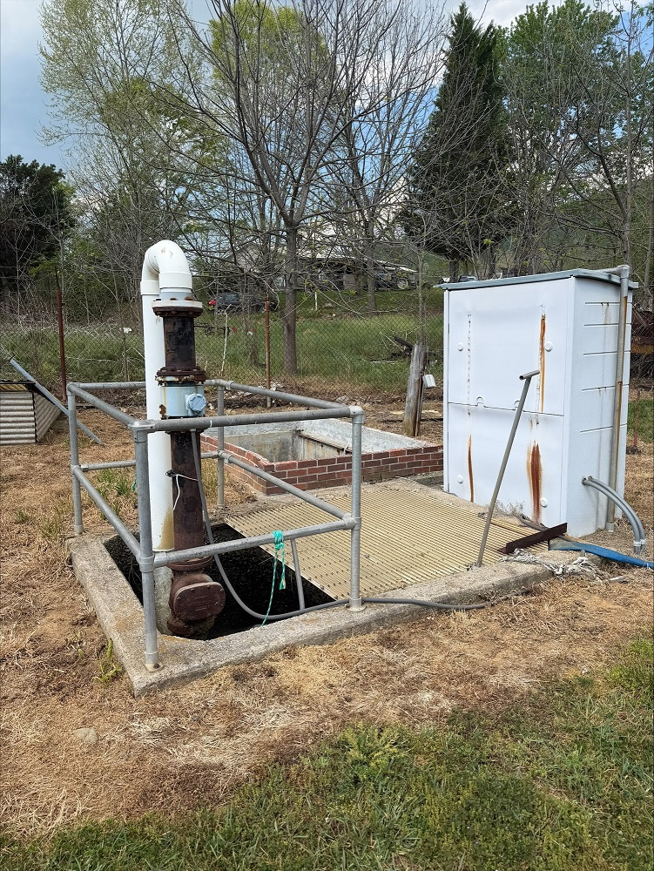
Note: Images represent existing conditions at the time of site visits (April 2026).

GENERAL INFORMATION FOR SUBMITTING PROPOSALS

I) EXCEPTIONS: All proposals are subject to the terms and conditions outlined herein. All responses shall be controlled by such terms and conditions, and the submission of other terms and conditions, price lists, catalogs, and/or other documents as part of an offeror's response will be waived and have no effect either on this Request for Proposals or on any contract that may be awarded resulting from this solicitation. The offeror agrees explicitly to the conditions set forth in the above paragraph by signing the proposal.
2) CERTIFICATION: By executing the proposal, the signer certifies that this proposal is submitted competitively and without collusion (G.S. 143-54), that none of our officers, directors, or owners of an unincorporated business entity has been convicted of any violations of Chapter 78A of the General Statutes, the Securities Act of 1933, or the Securities Exchange Act of 1934 (G.S. 143-59.2), and that we are not an ineligible vendor as set forth in
G.S. 143-59.1. False certification is a Class I felony.

3) ORAL EXPLANATIONS: The Town of Waynesville shall not be bound by oral explanations or instructions given at any time during the competitive process or after the award.
4) COST OF PROPOSAL PREPARATION: Any costs incurred by offerors in preparing or submitting offers are the offerors' sole responsibility; the Town of Waynesville le will not reimburse any offeror for any costs incurred.
- TIME FOR ACCEPTANCE: Each proposal shall state that it is a firm offer that may be accepted within a period of 45 days. Although the contract is expected to be awarded prior to that time, the 45-day period is requested to allow for unforeseen delay.
- HISTORICALLY UNDERUTILIZED BUSINESSES: The Town of Waynesville invites and encourages participation in this procurement process by businesses owned by minorities, women, disabled, disabled business enterprises, and non-profit work centers for the blind and severely disabled.
The Contractor agrees to maintain open hiring and employment practices and to receive applications for employment in compliance with all requirements of applicable federal, state, and local laws and regulations issued pursuant to its relating to nondiscriminatory hiring and employment practices. Each Contractor shall undertake an affirmative action program to ensure that no person shall be excluded from participation in any employment activities because of age, sex, race, religion, color, national origin, or handicap.
- PROTEST PROCEDURES: If an offeror wants to protest a contract awarded pursuant to this solicitation, they must submit a written request to the Purchasing Office, 129 Legion Drive, or P.O. Box 100, Waynesville, NC 28786. This request must be received by the Purchasing Division within thirty (30) consecutive calendar days from the date of the contract award and must contain specific sound reasons and any supporting documentation for the protest. NOTE: Contract award notices are sent only to those actual y awarded contracts and not to every person or firm responding to this solicitation. Contract status and award notices are available through the purchasing division (828) 456-3706.
8) TABULATIONS: Bidders may call the purchasing division to obtain a verbal status of contract award.

CONTRACT TERMS & CONDITIONS

1) INDEPENDENT CONTRACTOR: The Contractor shall be considered to be an independent contractor and, as such, shall be wholly responsible for the work to be performed and for the supervision of its employees. The Contractor represents that it has, or will secure at its own expense, all personnel required to perform the services under this agreement. Such employees shall not be employees of or have any individual contractual relationship with the Town of Waynesville.
2) KEY PERSONNEL: The Contractor shall not substitute key personnel assigned to the performance of this contract without prior written approval by the Town Manager. The individuals designated as key personnel for the purposes of this contract are those specified in the Contractor's proposal.
- SUBCONTRACTING: Work proposed to be performed under this contract by the Contractor or its employees shall not be subcontracted without prior written approval by the Town Manager. Acceptance of an offeror 's proposal shall include any subcontractor(s) specified therein.
- PERFORMANCE AND DEFAULT: If, through any cause, the Contractor shall fail to fulfill in a timely and proper manner the obligations under this agreement, the Town of Waynesville shall thereupon have the right to terminate this contract by giving written notice to the Contractor and specifying the effective date thereof. In that event, all finished or unfinished deliverable items under this contract prepared by the Contractor shall, at the option of the Town, become its property, and the Contractor shall be entitled to receive just and equitable compensation for any satisfactory work completed on such materials. Notwithstanding, the Contractor shall not be relieved of liability to the Town for damages sustained by the Town by virtue of any breach of this agreement, and the Town may withhold any payment due to the Contractor for the purpose of setoff until such time as the exact amount of damage due the Town of Waynesville le from such breach can be determined.
- 5) TERMINATION: The Town may terminate this agreement at any time by giving 15-day notice in writing from the Town to the Contractor. In that event, all finished or unfinished deliverable items prepared by the Contractor under this contract shall, at the option of the Town, become its property. If the contract is terminated by the Town of Waynesville, as provided herein, the Contractor shall be paid for services satisfactorily completed, less payment or compensation previously made.
6) CARE OF PROPERTY: The Contractor agrees that it shall be responsible for the proper custody and care of any property furnished for use in connection with the performance of this contract or purchased by it for this contract and will reimburse the Town for loss or damage of such property.
- ASSIGNMENT: No assignment of the Contractor's obligations nor the Contractor's right to receive payment hereunder shall be permitted. However, upon a written request approved by the issuing purchasing authority, the Town of Waynesville may:
- Forward the contractor's payment check(s) directly to any person or entity designated by the Contractor or
- Include any person or entity designated by the Contractor as joint payee on the Contractor's payment check(s).
In no event shall such approval and action obligate the Town to anyone other than the Contractor, and the Contractor shall remain responsible for fulfilling all contract obligations.

- COMPLIANCE WITH LAWS: The Contractor shall comply with all laws, ordinances, codes, rules, regulations, and licensing requirements (permits) that are applicable to the conduct of its business, including those of federal, state, and local agencies having jurisdiction and/or authority.
- AFFIRMATIVE ACTION: The Contractor shall take affirmative action in complying with all Federal and State requirements concerning fair employment and employment of people with disabilities and concerning the treatment of all employees without regard to discrimination by reason of race, color, religion, sex, national origin, or disability.
- INSURANCE: During the term of the contract, the contractor, at its sole cost and expense, shall provide commercial insurance of this type and with such terms and limits as may be reasonably associated with the contract. As a minimum, the contractor shall provide and maintain the following coverage and limits:
- Worker's Compensation - The contractor shall provide and maintain Worker's Compensation Insurance, as required by the laws of North Carolina, as well as employer's liability coverage with minimum limits of $150,000.00, covering all the Contractor's employees who are engaged in any work under the contract. If any work is subcontracted, the contractor shall require the subcontractor to provide the same coverage for any of its employees engaged in any work under the contract.
- Commercial General Liability - General Liability Coverage on a Comprehensive Broad Form on an occurrence basis in the minimum amount of $1,000,000.00 Combined Single Limit.
- Automobile - Automobile Liability Insurance, to include liability coverage, covering all owned, hired, and non-owned vehicles used in connection with the contract. The minimum combined single limit shall be $500,000. 00 for bodily injury and property damage, $500,000.00 for uninsured/underinsured motorists, and $100,000. 00 for medical payment.
Providing and maintaining adequate insurance coverage is a material obligation of the contractor and is of the essence of this contract. All such insurance shall meet all laws of the State of North Carolina. Such insurance coverage shall be obtained from companies that are authorized to provide such coverage and that are authorized by the Commissioner insurance to do business in North Carolina. The contractor shall at all times comply with the terms of such insurance policies and all requirements of the insurer under any such insurance policies, except as they may conflict with existing North Carolina laws or this contract. The limits of coverage under each insurance policy maintained by the contractor shall not be interpreted as limiting the contractor's liability and obligations under the contract.
The Contractor shall furnish a Certificate of Insurance as proof of the above coverages. The certificate will contain a provision that the insurance coverage cannot be canceled, reduced in amount, or eliminated without 30 days' written notice to the Town of
Waynesville. Owner's Protective insurance must list the Town of Waynesville as a "Named Insured" as its interest may appear. The owner's approval of Certificate of Insurance does not decrease or relieve the contractor's responsibility for maintaining insurance coverage as required in this Request for Proposal.

- ENTIRE AGREEMENT'. This contract and any documents explicitly incorporated by reference represent the entire agreement between the parties and supersede all prior oral or written statements or agreements. This Request for Proposals, any addenda thereto, and the offeror's proposal are incorporated herein by reference as though set forth verbatim.

All promises, requirements, terms, conditions, provisions, representations, guarantees, and warranties contained herein shall survive the contract expiration or termination date unless specifically provided otherwise herein, or unless superseded by applicable Federal or State statute of limitation
- AMENDMENTS: This contract may be amended only by written amendments duly executed by the Town and the Contractor.
- GENERAL INDEMNITY: The contractor shall hold and save the Town of Waynesville, its officers, agents, and employees, harmless from liability of any kind, including all claims and losses with the exception of consequential damages accruing or resulting to any other person, firm, or corporation furnishing or supplying work, services, materials, or supplies in connection with the performance of this contract, and from any and all claims and losses accruing or resulting to any person, firm, or corporation that may be injured or damaged by the contractor in the performance of this contract.
- MATERIALS: The Town of Waynesville is not responsible for any materials, equipment, or tools lost or stolen from the site.
- CLEAN-UP: The area of work shall be cleaned daily so that the Town shall not incur additional costs to make the area suitable for the work process. Also, the Contractor shall keep the public safe from construction debris by taking appropriate steps to close off access to the work area.
- PERFORMANCE OF WORK: All work shall be performed at the highest level of quality. The owner shall be responsible for determining the quality of work and may notify the Contractor of same. ANY WORK COMPLETED THAT IS NOT SUITABLE FOR THE OWNER SHALL BE REPEATED BY THE CONTRACTOR AT NO COST TO THE OWNER. Any damage to existing area or utilities will be the responsibility of the Contractor. NO EXCEPTIONS.

ADDITIONAL INSTRUCTIONS FOR BIDDERS

- SCOPE: Work shall consist of furnishing all labor, materials, equipment, and services incidental for the completion of work as described herein. All items not specifically mentioned in the specifications, but which obviously are required to make the job complete, should be included automatically.
- QUALIFICATIONS: All bidders must furnish a list of North Carolina Contractor Licenses which they hold.

- CONTRACTOR' S RESPONSIBILITY: The Contractor shall be responsible for the construction site during the performance of the work. The Contractor shall be responsible for any and all damages to persons and property during the performance of the work and shall further provide all necessary safety measures and shall fully comply with all federal, state, and local laws, building rules, rules, and regulations to prevent accidents or injury to persons or property on or about the location of the work site. This is to include OSHA 1910, General Construction, or those regulations mandated by these specifications. Special attention will be paid to proper barricading of the work areas due to the work progressing within an actively operating office atmosphere.
- SAFETY REGULATIONS: The Contractor shall adhere to the rules, regulations, and interpretations of the North Carolina Department of Labor relating to Occupational Safety and Health Standards for the Construction Industry (Title 29, Code of Federal Regulations, Part 1926, published in Volume 39, Number 122, Part II, June 24, 1974, Federal Register) which is hereby incorporated in these specifications.
- CODES: All work shall be done in accordance with the specifications and shall comply with the North Carolina Building Code, Underminers' Rules, and Regulations, and Federal, State, and Local Regulations covering work of this nature. Whenever drawings or specifications are in excess of such laws, codes, and regulations, the specifications shall hold. All equipment shall have U. L. Labels attached.
- WORK SCHEDULE: Construction can begin immediately.
- WORKERS ONJOB: All employees of the Contractor shall act in a professional and courteous manner.
- E-VERTFY: Contractor shall comply with E-Verify, the federal E-Verify program operated by the United States Department of Homeland Security and other federal agencies, or any successor or equivalent program used to verify the work authorization of newly hired employees pursuant to federal law and as in accordance with
N.C.G.S. 564-25 et seq. In addition, to the best of Contractor's knowledge, any subcontractor employed by Contractor as a part of this contract shall follow the requirements of E-Verify and N.C.G.S. S64-25 et seq.

- IRAN INVESTMENT ACT: North Carolina Local Government Units may not enter into contracts with any entity or individual found on The State Treasurer's Iran Final Divestment List N.C.G.S. 143C-6A. By bidding on this project, the bidder certifies it is not listed on the Final Divestment List created by the State Treasurer.
- DRUG FREE WORKPLACE: The Town of Waynesville has adopted a Drug-Free Workplace Policy requiring the contractor to ensure that a drug-free workplace is provided in the performance of this agreement. The requirements of that policy are included in the invitation to bid and included in the agreement of the Project.

- MINORITY/WOMAN BUSINESS ENTERPRISE (IMIWBE): It is the policy of the Town of Waynesville to ensure that all businesses, including MIWBE's, are afforded the maximum practical opportunity to participate in the Town's purchasing and contracting processes. Therefore, the Town will not enter into a contract with any business entity that has discriminated in the solicitation, selection, hiring, or

commercial treatment of vendors, suppliers, subcontractors, or commercial customers on the basis of race, color, religion, national origin, sex, age, or handicap.

** THE IDENTIFICATION OF THE MINORITY BUSINESS PARTICIPATION FORM AND THE LISTING OF GOOD FAITH EFFORTS, AFFIDAVIT "A" MUST BE INCLUDED WITH EACH BID
FOR THE BID TO BE RESPONSIVE **

- CONFLICT OF INTEREST: No officer, employee, or agent of the Town and no sub­ grantee or sub-recipient of any federal or state funds from the Town shall participate in the selection or the award or administration of a contract supported by federal, state, or City funds if a conflict of interest, real or apparent, is involved.
Such a conflict of interest arises when any of the following people or entities have a financial or other interest in the firm selected for the award:
iJ The employee, officer, agent,
  - Any member of his or her immediate family,
  - His or her partner, or
iv) An organization that employs or is about to employ anyone listed in (1) and (2) above.
The grantee or subgrantee's officers, employees, or agents will not solicit or accept gratuities, favors, or anything of monetary value from contractors, potential contractors, or parties to sub-agreements except as may be allowed in the Town's Gift Policy.

- DIVESTMENT FROM COMPANIES BOYCOTTING ISRAEL CERTIFICATION: As of the
date of this Agreement, the Contractor certifies that it is not listed on the Final Divestment and Do-Not Contract List of Restricted Companies Boycotting Israel created by the State Treasurer pursuant to N.C.G.S. 147-86.81 and that the Contractor will not utilize any subcontractor found on the State Treasurer Final Divestment and Do-Not Contract List. All individuals signing this contract on behalf of the Contractor certify that they are authorized by the Contractor to make this certification

