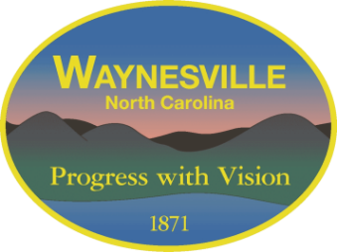
Gary Caldwell, Mayor Rick Howell, Interim Town Manager
Chuck Dickson, Mayor Pro Tem Martha Sharpe Bradley, Town Attorney
Julia Freeman, Councilmember
Jon Feichter, Councilmember
Anthony Sutton, Councilmember

PUBLIC NOTICE
Community Infrastructure Program Public Hearing

The Town of Waynesville hereby gives notice that a public hearing will be held during the regularly scheduled Town Council meeting on August 11, 2026, at 6:00 p.m. at 9 S Main Street, Waynesville, NC 28786 In Council Chambers to discuss the submission of an application for funding under the North Carolina Department of Commerce Community Infrastructure Program funded through Community Development Block Grant – Disaster Recovery (CDBG-DR) funds.
The Town of Waynesville intends to apply for approximately $1,000,000 or more through the North Carolina Department of Commerce Community Infrastructure Program. The program is funded through Community Development Block Grant – Disaster Recovery (CDBG-DR) funds. The final grant request amount is currently being determined and will be based on the final project cost estimate and eligible project expenses.
Proposed Project: Walnut Trail Bridge Rehabilitation Project
The proposed project will rehabilitate and strengthen the Walnut Trail Bridge by addressing long-standing structural needs and storm-related damage, improving the bridge’s load capacity and resilience, and ensuring continued access to the Town’s Wastewater Treatment Plant and nearby residences.
The proposed application is currently being prepared and is anticipated to be submitted by the September 8, 2026 due date.
Citizens are encouraged to attend the public hearing and provide comments regarding the proposed project and application. Written comments will also be accepted during the required 10-day public comment period beginning August 11, 2026, and ending August 21, 2026. All written comments must be received no later than August 21, 2026, prior to submission of the application. All comments received by the deadline will be considered before the application is submitted.
For additional information, to request a copy of the proposed application, or to submit written comments, please contact:

Breanna Jaquish
Grants Manager
Town of Waynesville
P.O. Box 100
Waynesville, NC 28786
Phone: 828-456-3515, Ext. 2232
Email: bjaquish@waynesvillenc.gov
The Town of Waynesville encourages all interested residents, community organizations, and stakeholders to participate and provide input regarding the proposed application. The Town will consider all comments received during the public hearing and public comment period prior to submission of the application.
Posted/Published: July 27, 2026

