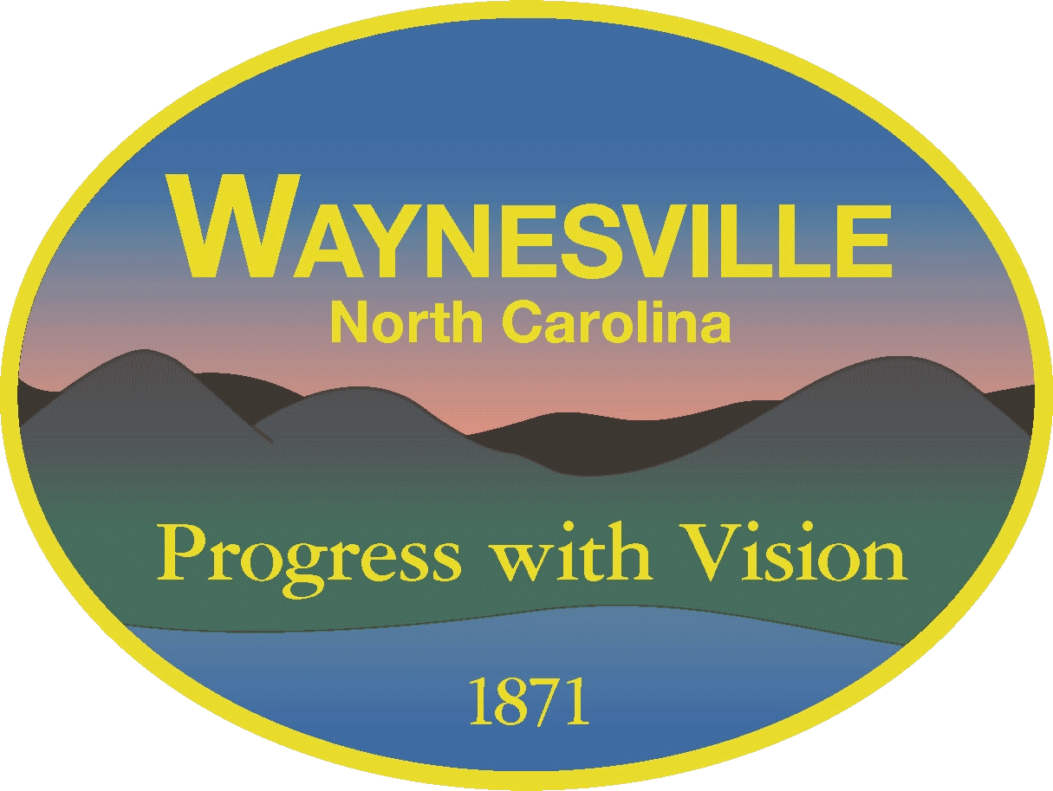
TOWN OF WAYNESVILLE
Mulch Access Request Form
Public Works Department

Applicant Information:
- Full Name: _________________________________________
- Address: ___________________________________________
- City / State / Zip: __________________________________
- Phone Number: ______________________________________
- Email Address: ______________________________________
- Are you a resident of the Town of Waynesville?
☐ Yes ☐ No

Mulch Request Details:
- Type
☐ Mulch
☐ Compost
- Requested Quantity:
☐ One Load
☐ Multiple Loads (specify number: ___)
- Preferred Pickup Date: _______________________

Terms & Conditions:
- Mulch is provided as-is and availability is not guaranteed.
- The Town of Waynesville is not liable for any damage to vehicles or property during loading, unloading, or use.
- Residents may be limited to a certain number of loads per year.
- Mulch must not be resold or redistributed for profit.
☐ I have read and agree to the above terms and conditions.
Signature: ___________________________________ Date: _______________

Office Use Only:
- Request Received By: ___________________________ Date: ______________
- Residency Verified: ☐ Yes ☐ No
- Approved By: _________________________________
- Pickup/Delivery Scheduled for: __________________
- Notes: ___________________________________________________________

Submission Instructions:
Submit completed forms to:
Town of Waynesville Public Services Department
129 Legion Dr Waynesville, NC 28786
Email: ewoody1@waynesvillenc.gov
Phone: 828-456-3706
Office Hours: Monday-Friday 7am-4pm

