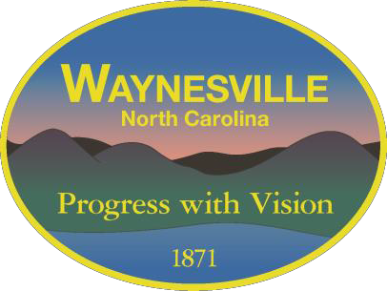
TOWN OF WAYNESVILLE, NORTH CAROLINA
Application for Appointment to Boards/Commissions
Please return to the Town Clerk’s office.
16 South Main Street, P.O. Box 100, Waynesville, NC 28786
(828) 452-2491
cpoolton@waynesvillenc.gov
Additional Pages and/or a resume may be attached but is not required
NAME STREET ADDRESS MAILING ADDRESS PHONE E-MAIL
Please consider me for re-appointment to the following board(s) or commission(s):
Alcoholic Beverage Control Board Planning Board

Board of Adjustment
Public Art Commission

Downtown Waynesville Commission
Recreation & Parks Advisory Commission

Historic Preservation Commission Waynesville Housing Authority
Environmental Sustainability Board Cemetery Committee
**As of July 27, 2021, the Town Council now require applicants to any Board and Commission required by statute to be interviewed by the Town Council. These Boards and Commissions are the Planning Board, Zoning Board of Adjustment, Alcohol Beverage Control Board, and the Waynesville Housing Authority.
I am interested in serving on this board or commission because:

I have experience/expertise in the following areas and/or have served on the following board or commission:

I feel that I can contribute the following to this board or commission

Tell us about yourself and your background:

If a vacancy exists and I qualify for appointment, I will be contacted for my permission to the appointment. If I am chosen, I will faithfully execute my duty on the selected board or commission.

Signature

Upon appointment to a Board/Committee, the information contained herein becomes a matter of public record per NCGS 132-1.
Return Application to Town Clerk’s Office

Date

